

**North South University**

**Department of Electrical & Computer Engineering**

**LAB REPORT**

**Analog Electronics Lab**

**EEE111L**

**Experiment Number:** 2

**Experiment Name:** Diode Rectifier circuits

**Experiment Date:** 1/11/2021

**Report Submission Date:** 8/11/2021

**Section:** 7 **Group No:** 2

**Students Name & ID:**

1. Md Kawser Islam – 1912296642 **(Report Writer)**
2. Yusuf Abdullah Tonmoy – 1620456042
3. Fardin Bin Islam - 1721588642
4. Tusher Saha Nirjhor – 1921793642
5. Md. Rifat Ahmed – 1931725042

|  |  |  |
| --- | --- | --- |
| **Remarks:** | Score |  |
|  |  |
|  |  |  |
|  |  |  |

**Objectives:**

• Our objective in this experiment is to study different diode rectifier circuits.

**Theory:**

A rectifier an electrical device which converts an alternating current into a direct one by allowing a current to flow through it in one direction only. The key component in any rectifier circuit is naturally the diode or diodes used. A rectifier converts an AC signal into a DC signal. From the characteristic curve of a diode, we observe that if allows the current to flow when it is in the forward bias only. In the reverse bias it remains open.

So, when an alternating voltage (signal) is applied across a diode it allows only the half cycle (positive half cycle depending on the orientation of diode in the circuit) during its forward bias condition, the other half cycle will be clipped off. In the output the load will get a DC signal.

Diode rectifiers can be categorized in two major types. They are –

Half-wave rectifier.

Full-wave rectifier.

**Half - Wave Rectifier:** Half-wave rectifiers transform AC voltage to DC voltage. A Half wave rectifier circuit uses only one diode for the transformation.

Half-wave rectifier can be built by using a single diode. The circuit diagram and the wave shapes of the input and output voltage of half wave rectifier are shown below:

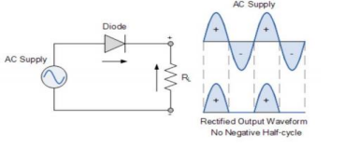

Figure: Half Wave Rectifier

There are some disadvantages of Half-wave rectifier. The major disadvantages of half wave rectifier are -

• In this circuit the load receives approximately half of input power.

• Average DC voltage is low.

• Due to the presence of ripple output voltage is not smooth one.

**Full Wave Rectifier:** A full wave rectifier converts both halves of each cycle of an alternating wave (AC signal) into a pulsating DC signal. Full-wave rectifiers are used to convert AC voltage to DC voltage, requiring multiple diodes to construct. Full wave rectification is the process of converting an AC signal to a DC signal.

Circuits that convert alternating current (AC) into direct current (DC) are known as rectifiers. If such rectifiers rectify both the positive and negative half cycles of an input alternating waveform, the rectifiers are full-wave rectifiers.

In the full-wave rectifier both the half cycle is present in the output. Two circuits are used as full-wave rectifier are shown in below-

➢ Full-wave rectifier using center-tapped transformer.

➢ Full-wave bridge rectifier.

**Full-wave rectifier using center-tapped transformer:** In Full-wave rectifier using center tapped transformer, two diodes will be connected to the ends of the transformer and the load will be between the diode and center tap. The circuit diagram and the wave shapes are shown in below

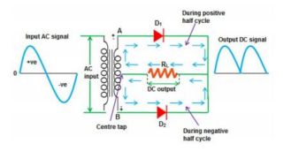

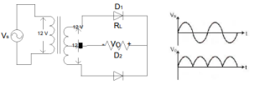

Figure: Full Wave Rectifier using center tapped transformer

Full-wave rectifier using center-tapped transformer circuit has some advantages over full wave rectifier. Those are -

▪ Wastage of power is less.

▪ Average DC output increase significantly.

▪ Wave shape becomes smoother.

There is also some disadvantage of full-wave rectifier using center-tapped transformer. These are -

• Require more space and becomes bulky because of the transformer. • Not cost effective (for using transformer).

**Full-wave bridge rectifier:** To rectify both half-cycles of a sine wave, the bridge rectifier uses four diodes, connected together in a “bridge” configuration. The secondary winding of the transformer is connected on one side of the diode bridge network and the load on the other side. A bridge rectifier overcomes all the disadvantages of described above. Here four diodes will be connected as bridge connection. The circuit diagram and the wave shapes are shown in bellow –

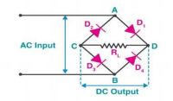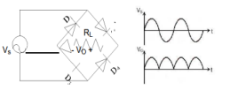

Figure: Full Wave Bridge Rectifier

During positive half cycle of the source, diodes D1 and D2 conduct while D3 and D4 are reverse biased. This produces a positive load voltage across the load resistor

This rectifier however cannot produce a smooth DC voltage. It produces some ripple in the output. This ripple can be reducing by using filter capacitor across the load.

**Equipment List:**

• p-n junction diode (1N4007) – 4 pieces

• Resistor (10kΩ) – 1 piece

• Capacitor (0.22µF, 10 µF) – 1 piece each

• Signal generator

• Trainer Board

• Oscilloscope

• Digital Multimeter

• Cords and wires

**Circuit Diagram:**

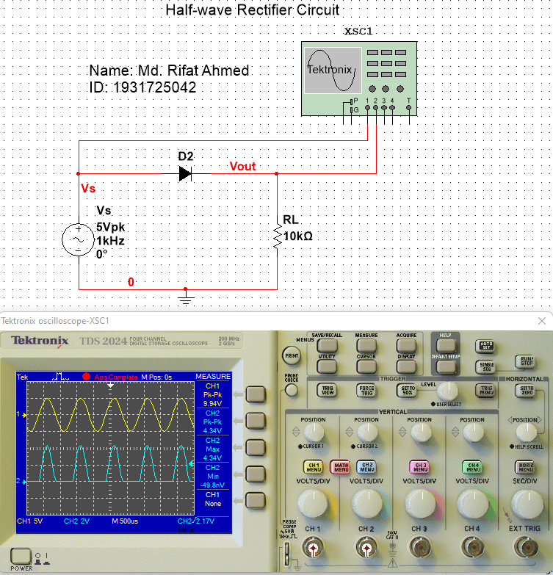

Figure – 1: Half-wave Rectifier Circuit with No Capacitor

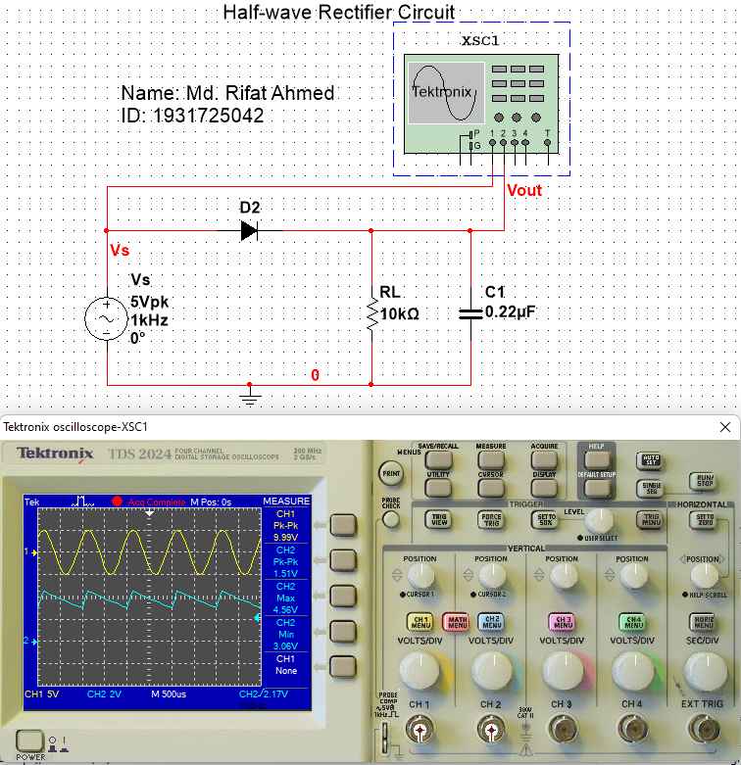

Figure – 2: Half-wave Rectifier Circuit with 0.22µF Capacitor

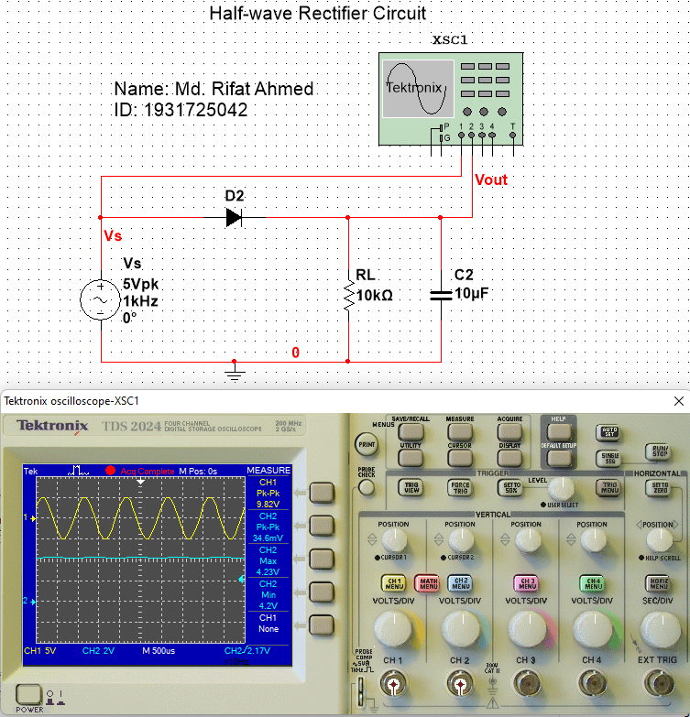

Figure – 3: Half-wave Rectifier Circuit with 10µF Capacitor

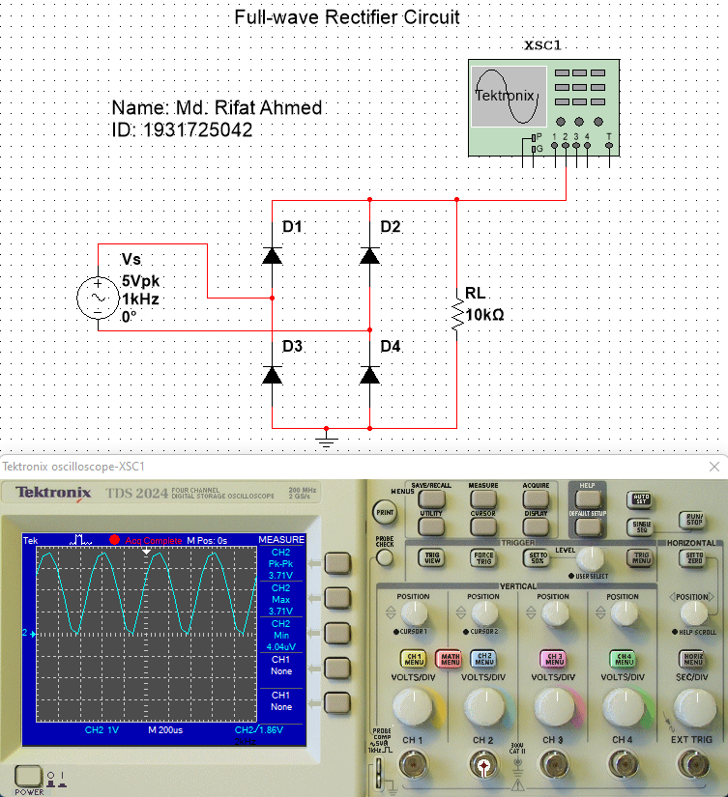

Figure – 4: Full-wave Rectifier Circuit with No Capacitor

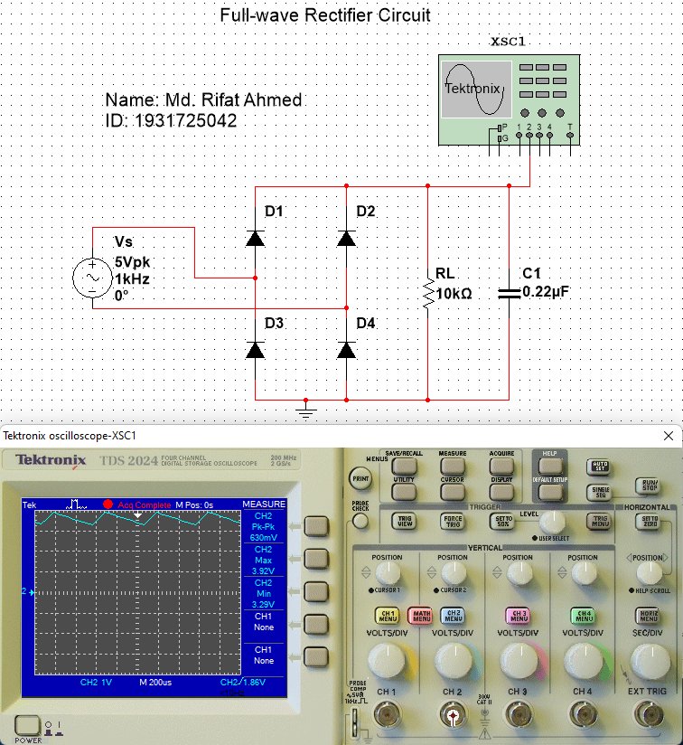

Figure – 5: Full-wave Rectifier Circuit with 0.22µF Capacitor

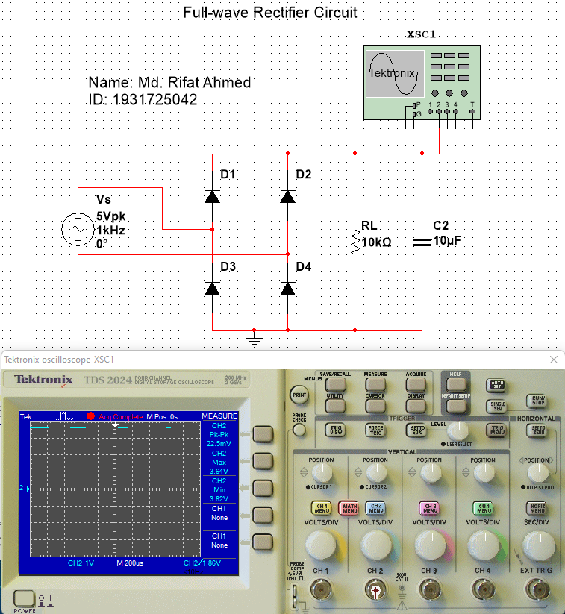

Figure – 6: Full-wave Rectifier Circuit with 10µF Capacitor

**Data & Table:**

Theoretical Value: R = 10kΩ

Measured Value: R = 10kΩ

|  |  |  |
| --- | --- | --- |
|  | **Half Wave Rectifier**  **(Fig 2.4)** | **Full Wave Rectifier**  **(Fig 2.5)** |
| **Vout**  **(without capacitor)** | 4.34 V | 3.71 V |
| **Vout (with 0.22 µF)** | 1.51 V | 630 mV |
| **Vout (with 10 µF)** | 34.6 mV | 22.5 mV |

Table - 1

**Graph:**

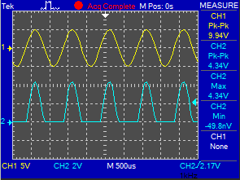 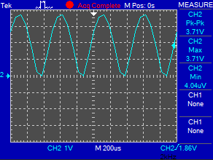

a) Input-output without capacitor (Fig. 1) d) Input-output without capacitor (Fig. 4)

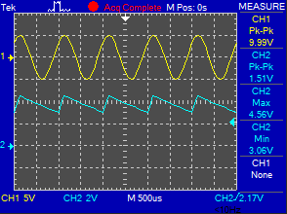 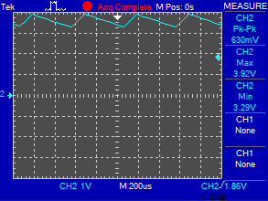

b) Input-output with 0.22uF (Fig. 2) e) Input-output with 0.22uF (Fig. 5)

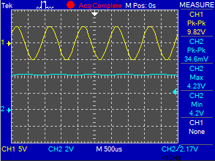 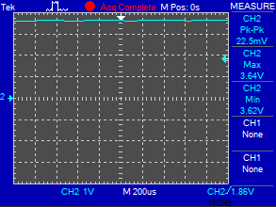

c) Input-output with 10uF (Fig. 3) f) Input-output with 10uF (Fig. 6)

**Result Analysis & Discussion:**

Diode rectifier circuit is one of the main circuits which is used in electronic equipment. A rectifier converts an AC signal into a DC signal. In this experiment we learnt about rectifier circuits. In a half wave rectifier circuit there’s only one diode whereas in a full wave rectifier circuit there are four diodes. In a half wave rectifier, the load receives only half of the total input power and due to the presence of ripple output voltage wave is not smooth. On the other hand, a full wave rectifier is designed using a bridge so it has both the half cycle present in the output voltage. Which is why in a full wave rectifier the output wave is smoother. And during this experiment we saw that for both half wave and full wave rectifier there was a curve when no capacitor was added to the circuit. But when we added a 0.22μF capacitor to both they started giving smaller waves and as we increased the capacitance to 10μF the lines in both the circuit got flattened for peak-to-peak voltage meaning the AC source were almost acting like an DC source. So, by adding more capacitance we can make a rectifier circuit with an AC source act like an DC source.

**Questions / Answers:**

**Answer to question 1:**

Here, we have to show the graphs of both circuits without any capacitor then with 0.22µF, and then with the 10µF.

 

a) Input-output without capacitor (Fig. 1) d) Input-output without capacitor (Fig. 4)

 

b) Input-output with 0.22uF (Fig. 2) e) Input-output with 0.22uF (Fig. 5)

 

c) Input-output with 10uF (Fig. 3) f) Input-output with 10uF (Fig. 6)

**Answer to question 2:**

Without capacitor, we got 4.34 V for half-wave rectifier circuit and 3.71 V for full-wave rectifier circuit. So, the peak to peak value is more in half wave rectifier circuit. But we got both positive and negative half-cycles for full-wave rectifier circuit whereas half-wave rectifier circuit only gives the positive half cycles. In half-wave rectifier output wave, it gets charged then it holds the supply until the supply of input AC toward the rectifier achieves the negative half cycle. Once the rectifier reaches to negative half cycle, the diode acquires reverse biased & stops letting the flow of current through it. In full-wave rectifier wave, in both the half cycles, the flow of current will be in the similar direction across the load resistor. Thus, we acquire either whole positive half cycle otherwise negative half cycle. Then, with .22μ capacitor, we got 1.51 V for half-wave rectifier circuit and 630 mV for full- wave rectifier circuit. So, the peak to peak value is more in half-wave rectifier circuit. Though voltage dropped more in half-wave rectifier circuit after adding .22μ capacitor. But both waves became close enough to DC wave. Lastly, with 10μ capacitor, we got 34.6 mV for half-wave rectifier circuit and 22.5mV for full- wave rectifier circuit. So, the peak to peak value is more in half-wave rectifier circuit. Though voltage dropped more in full-wave rectifier circuit after adding 10μ capacitor. In both circuits, we see the waves became horizontal wave that means the waves does not depend on time anymore which indicates the DC wave. Though, the half-wave rectifier produces pulsating DC voltage

**Answer to question 3:**

If we change the input signal frequency, for half- wave rectifier circuit, we will get equal supply as input frequency and double for full-wave rectifier. Frequency is measured by how frequently the period is completed in one second. A Time period (denoted by 'T' ) is the time needed for one complete cycle of vibration to pass in a given point. The output signal completes a period equal or twice as fast as the input frequency, as we can see in the graph. But, for 10μ capacitor, we will get 0 frequency as the wave does not depend on time anymore.

**Answer to question 4:**

Of course, the full wave circuit produces smoother output. Half wave rectifier is a low- efficiency rectifier while the full wave is a high-efficiency rectifier. Thus, it is always better for working on the highly efficient application. In our data table we see that the output voltages are less for full-wave rectifier. The output of a full-wave rectifier is much easier to filter than that of a half-wave rectifier because we know that he greater the load current, the more rapid the discharge of the capacitor, and the lower the average value of output voltage. Easier filter process gives smooth output so it’s crystal clear that, the full wave circuit produces smoother output.

**Contributions:**

|  |  |
| --- | --- |
| **Name & ID** | **Contribution** |
| Md Kawser Islam – 1912296642  (**Report Writer)** | Theory, Equipment List |
| Yusuf Abdullah Tonmoy - 1620456042 | Data & Table |
| Fardin Bin Islam - 1721588642 | Questions/Answers |
| Tusher Saha Nirjhor - 1921793642 | Result Analysis & Discussion |
| Md. Rifat Ahmed - 1931725042 | Graph, Circuit Diagram, Attachment |

**Attachment:**

**Task: 01**

Table- 2.1

|  |  |  |
| --- | --- | --- |
|  | **Half Wave Rectifier**  **(Fig 2.4)** | **Full Wave Rectifier**  **(Fig 2.5)** |
| **Vout**  **(without capacitor)** | 4.34 V | 3.71 V |
| **Vout (with 0.22 µF)** | 1.51 V | 630 mV |
| **Vout (with 10 µF)** | 34.6 mV | 22.5 mV |

**Task: 02**

Attach the screenshots of the simulated circuits with i/o waveforms below:



Figure – 1: Half-wave Rectifier Circuit with No Capacitor



Figure – 2: Half-wave Rectifier Circuit with 0.22µF Capacitor



Figure – 3: Half-wave Rectifier Circuit with 10µF Capacitor



Figure – 4: Full-wave Rectifier Circuit with No Capacitor



Figure – 5: Full-wave Rectifier Circuit with 0.22µF Capacitor



Figure – 6: Full-wave Rectifier Circuit with 10µF Capacitor

Attach only waveforms below:

 

1. *Input-output without capacitor (Fig. 1) d) Input-output without capacitor (Fig. 4)*

 

1. *Input-output with 0.22uF (Fig. 2)*  e) *Input-output with 0.22uF (Fig. 5)*

 

1. *Input-output with 10uF (Fig. 3)* f) *Input-output with 10uF (Fig. 6)*

**References:**

1. [Electronics Notes: reference site for electronics, radio & wireless (electronics-notes.com)](https://www.electronics-notes.com/)

2. [Half Wave Rectifier – Circuit Diagram, Theory & Applications (electrical4u.com)](https://www.electrical4u.com/half-wave-rectifiers/)

3. [Full Wave Rectifier - Definition, Circuit Construction, Working, Advantages (byjus.com)](https://byjus.com/physics/full-wave-rectifier/)

4. [Electronics Tutorial, Basic Physics, Online Tests, Computer Basics, Concepts of Physics (physics-and-radio-electronics.com)](https://www.physics-and-radio-electronics.com/)